Anthony Wilhelm

110 Cherry St.

Charlevoix, MI

49720

CIS104A EX9

**9.3 Real Estate: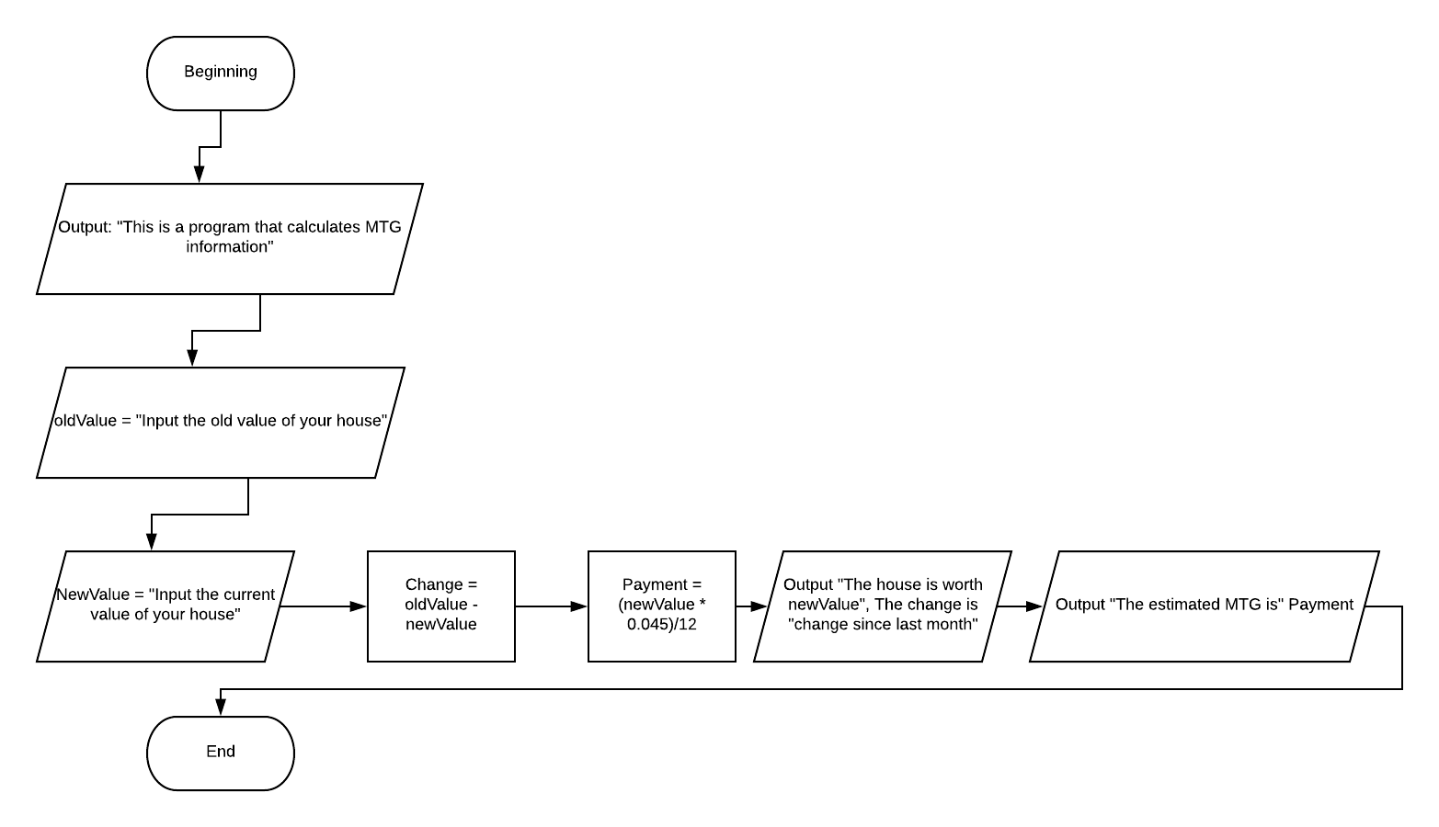Code:**

print("This is a program that calculates monthly mortgage\n")

newValue = int(input("What was price previously?: $"))

oldValue = int(input("\nWhat is the current price?: $"))

change = oldValue - newValue

payment = (newValue * 0.045)/12

print ("The house is worth", newValue, "\nThe change is", change, "since last month\n")

print ("The estimated mortgage is: $", payment)

**9.13 Leap Year:**

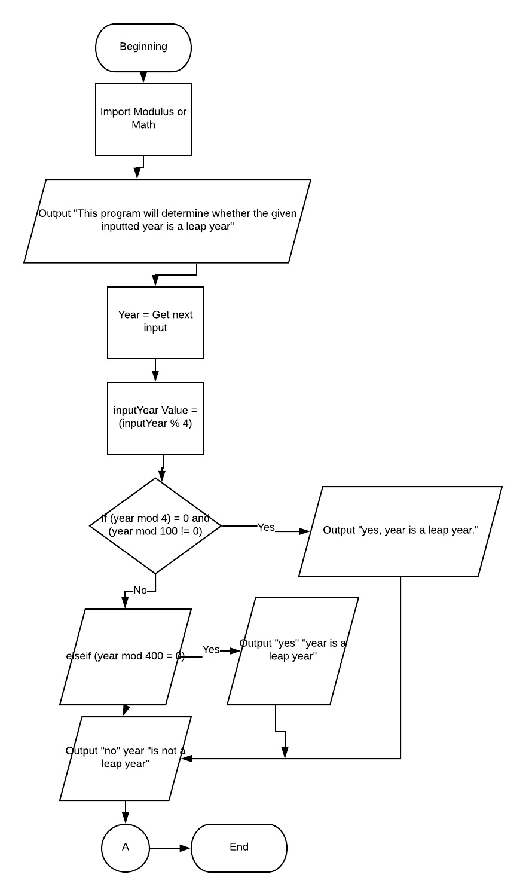

**Code:**

print("This program will determine whether the given inputted year is a leap year\n")

import math

inputYear = int(input("Please input a year: "))

inputYearValueA = (inputYear % 4)

if inputYearValueA == 0:

print(inputYear, "was a Leap Year.")

else:

print(inputYear, "was not a Leap Year.")

**9.15 Varied Amount of Input:**

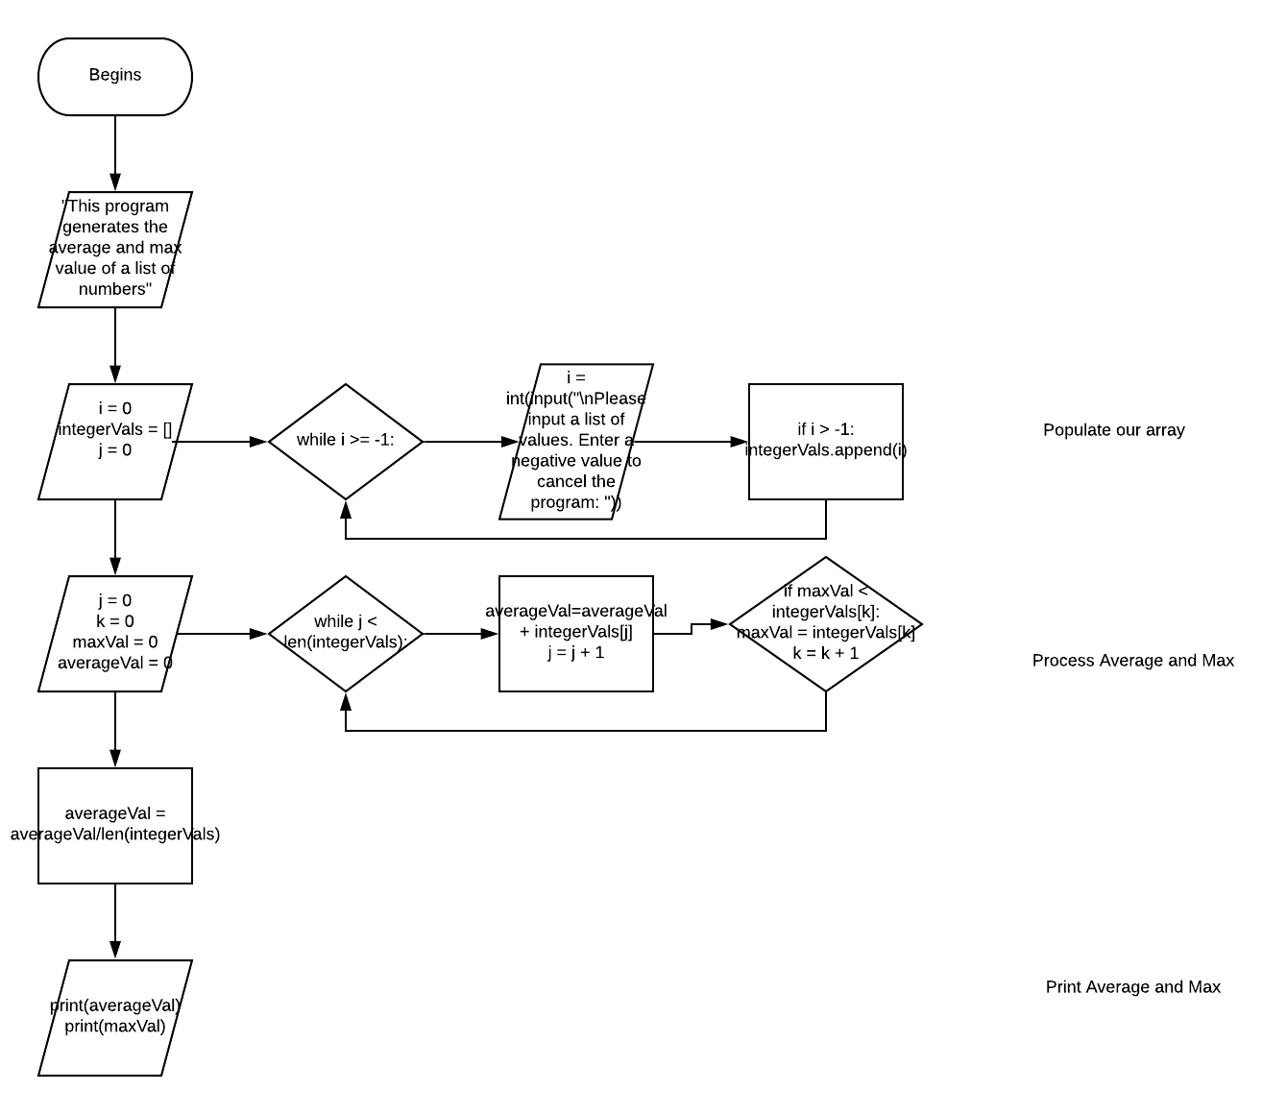

**Code:**

i = 1

integerVals = []

print("This program generates the average and max value of a list of numbers.\nInput a negative value to terminate the program: ")

j = 0

while i > -1:

i = int(input("\nPlease input a list of values. Enter a negative value to cancel the program: "))

if i > -1:

integerVals.append(i)

j = 0

averageVal = 0

k = 0

maxVal = 0

while j < len(integerVals):

averageVal = averageVal + integerVals[j]

j = j + 1

if maxVal < integerVals[k]:

maxVal = integerVals[k]

k = k + 1

averageVal = averageVal / len(integerVals)

print(averageVal)

print(maxVal)

**9.24 Driving Cost:**

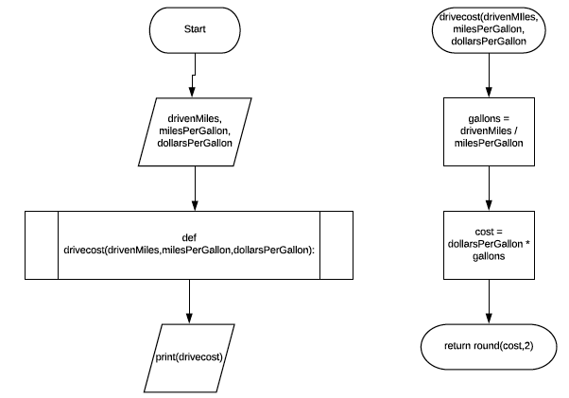

**Code:**

def drivecost(drivenMiles,milesPerGallon,dollarsPerGallon):

gallons = drivenMiles / milesPerGallon

cost = dollarsPerGallon * gallons

return round(cost,2)

print(drivecost(10.0,24.0,3.50))

def drivecost(drivenMiles,milesPerGallon,dollarsPerGallon):

gallons = drivenMiles / milesPerGallon

cost = dollarsPerGallon * gallons

return round(cost,2)

print(drivecost(50.0,24.0,3.50))

def drivecost(drivenMiles,milesPerGallon,dollarsPerGallon):

gallons = drivenMiles / milesPerGallon

cost = dollarsPerGallon * gallons

return round(cost,2)

print(drivecost(400.0,24.0,3.50))